BANQUET AUGUST 7, 2021
RIDER MUST BE PRESENT/ARENA OBLIGATION FULFILLED
Place: KOA (Campground of America). Hwy 441 Next to Dodge dealer .(subject to change)
Time: 1pm
Pot-Luck: It is expected that every rider bring a covered dish. Show will supply drinks, ice, paper products, etc.
Games: 50/50 Gift raffle Please bring a small gift to raffle eg . Picture frames, horse supplies, etc. MANY RAFFLES AND GIVEAWAYS!!
Tickets will be 6 for $ 5.00 or $1.00 a piece 10$ arm length 20$ both arms
BRING CASH!!!! WE NEED SMALL BILLS ONLY PLEASE!!!!!!!!!!!!!!!!!!!!!!!!!!
Next season $100 Family Season Entry Fee
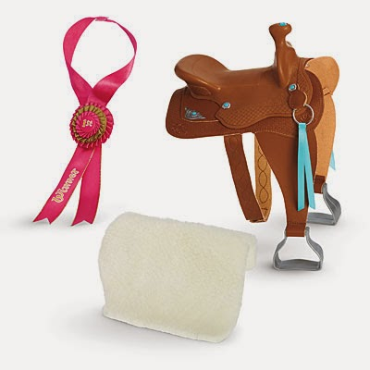
$70.00 Individual Season Entry Fee Show Fee $45

E-mail: pedaltothemetal@yahoo.com
Like us on MeWe: Pedal to the Metal Speed Show www.mewe.com
Webpage: www.pedaltothemetal.net
Dial @speedshow to number 81010 for updates

